**Data-Driven Pricing Strategy for Big Mountain Resort**

**Problem Statement**

Big Mountain Resort aims to increase its revenue by 15% and profit by 20% by the end of the next ski season (12 months). To achieve this, a data-driven pricing strategy is needed that considers the value customers place on the resort's facilities and services.

**Data Wrangling**

Cleaned the data and looked at ticket prices to maximize revenue and profit, reducing the data to 281 rows by removing rows with missing values in the AdultWeekend and AdultWeekday ticket prices columns. To focus on one ticket price variable, a target price point was modeled to predict corresponding prices.

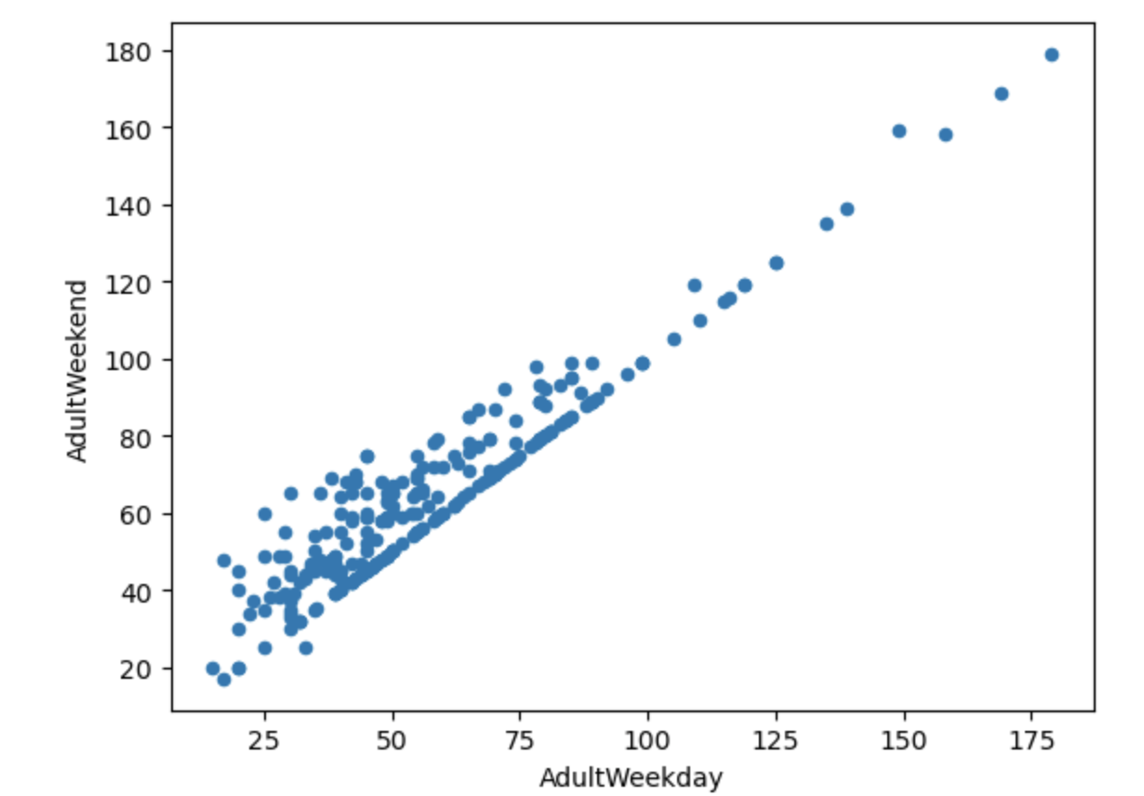

**Exploratory Data Analysis**

Summary statistics, principal component analysis, and scatterplots were used to analyze the relationship between ticket price and various features, such as resort density, vertical drop, fast quads, and summit elevation. The ratio of chairs to runs was found to have a negative correlation with the ticket price, while vertical drop, fast quads, runs, and total chairs were useful features for predicting ticket prices. Multicollinearity, non-linear relationships, and outliers were considered in feature selection.

**Model Preprocessing With Feature Engineering**

The performance of two machine learning models was evaluated for predicting ticket prices. The first model was a simple linear regression model, and the second was a random forest regressor. The random forest regressor outperformed the linear regression model due to its ability to handle non-linear relationships between features and the target variable.

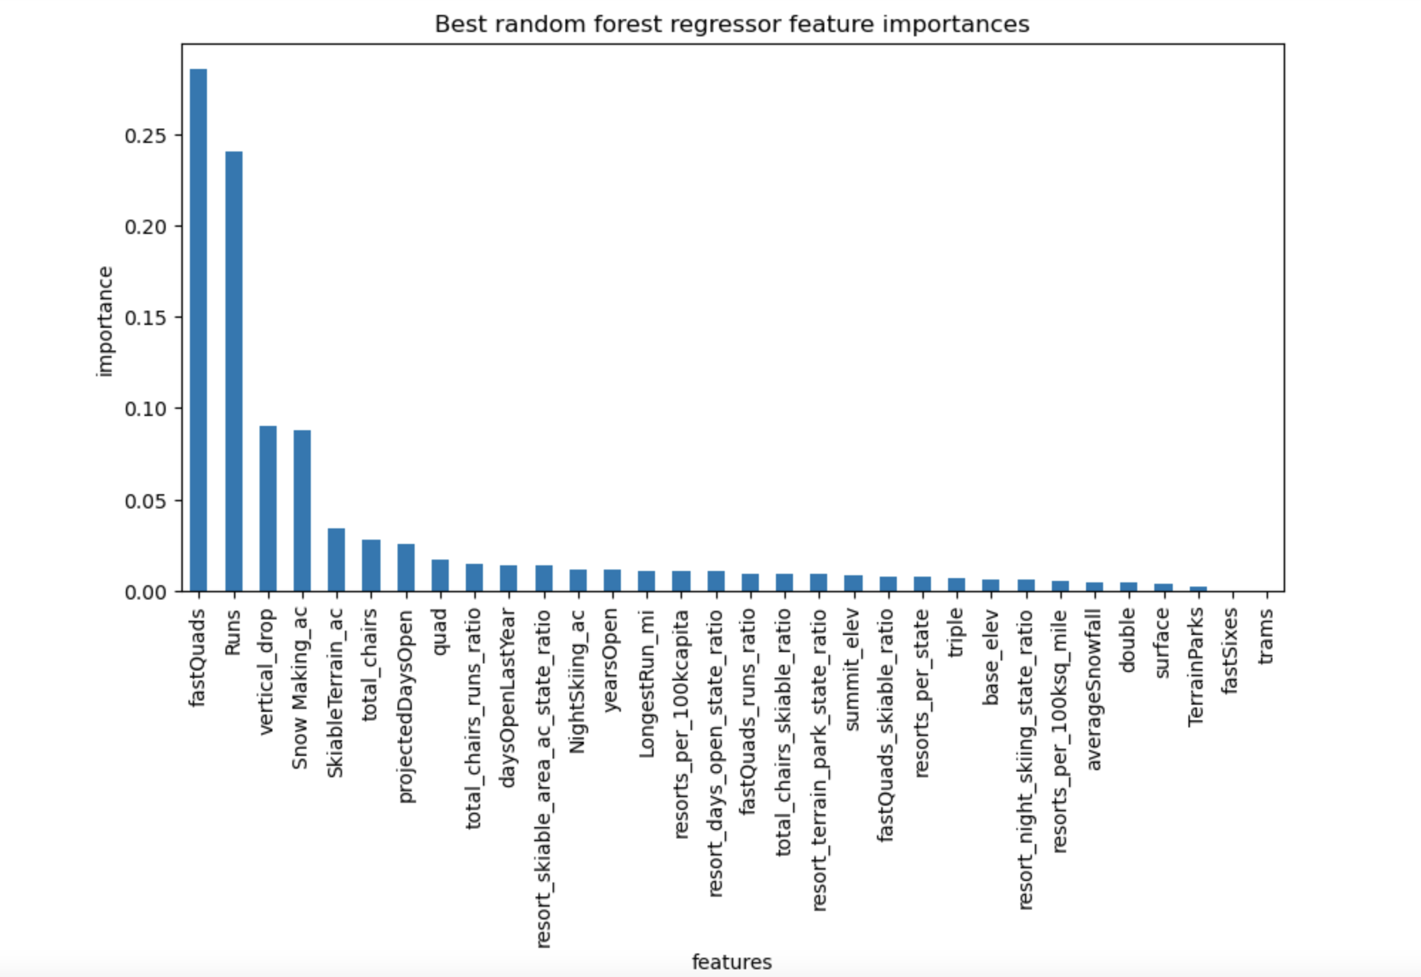

**Algorithms Used to Build the Model With Evaluation Metric**

The random forest regressor was used to build the model, and its performance was evaluated through cross-validation, with an estimated error of almost $1 compared to the real price.

**Winning Model and Scenario Modeling**

The random forest regressor was the winning model due to its better performance. The model was also used to estimate the cost of a new chair lift and potential run closures.

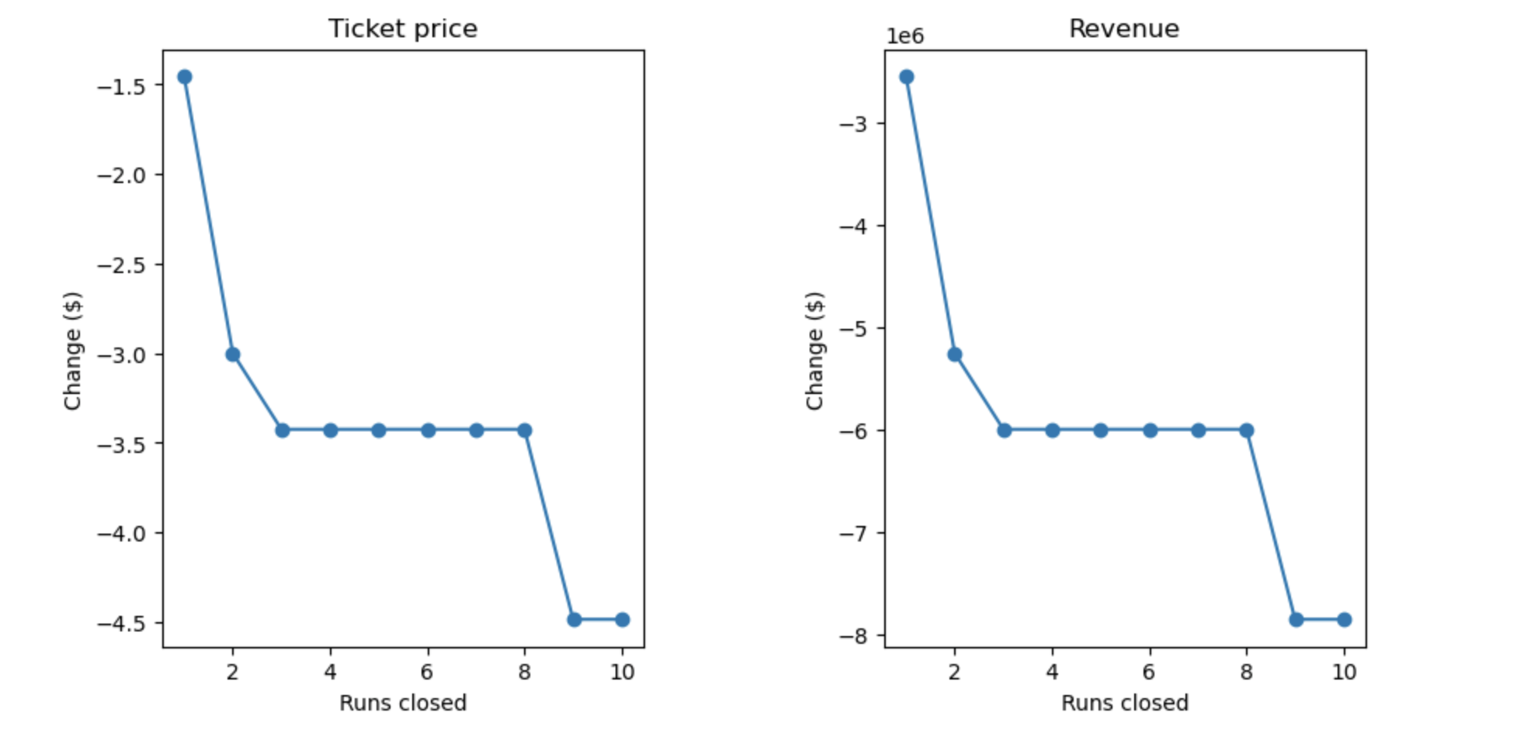

**Pricing Recommendation**

Based on the modeling, Big Mountain could increase its ticket price to $104.03, but the company should conduct further analysis of the market and competitors' pricing strategies. A slight increase in ticket prices could absorb the cost of a new features, such as an additional chair lift. The company could also test potential run closures through customer surveys and monitor ski traffic and ticket sales to adjust their plans based on the results.

**Conclusion**

The use of a data-driven approach to pricing strategy can help Big Mountain Resort increase its revenue and profit. The random forest regressor was the best model for predicting ticket prices based on its performance and ability to handle non-linear relationships. Big Mountain could increase its ticket price to $104.03, but additional analysis is necessary to determine if this price point is competitive.

**Future Scope of Work**

Future work could involve additional analysis of the market and competitors' pricing strategies, testing potential run closures through customer feedback, and monitoring ski traffic and ticket sales to adjust plans accordingly. Additionally, Big Mountain Resort could consider additional features, such as snow quality and weather, in its pricing strategy.